**STUDENT PORTFOLIO MANAGEMENT SYSTEM USING AWS**

*Prepared in the partial fulfillment of the Summer Internship Program on AWS*

AT



**Under the guidance of**

**Narmada Mani**

**Meenakshi K**

**August 2023**

***Submitted by***

***Shaik Basheer AP21110010203***

***Y. Baladithya AP21110010210***

***M.Durga Mahesh AP21110010242***

***SRM University AP***

*(August, 2023)*

## ACKNOWLEDGEMENT

I would like to express my heartfelt gratitude to all those who have contributed to the successful completion of my summer internship project at **Andhra Pradesh Skill Development Corporation (APSSDC)**. This opportunity has been an enriching and transformative experience for me, and I am truly thankful for the support, guidance, and encouragement I have received along the way.

First and foremost, I extend my sincere regards to Mrs Sumana Bethala and Mr Rama Krishna, my supervisors and mentors, for providing me with valuable insights, constant guidance, and unwavering support throughout the duration of the internship. Their expertise and encouragement have been instrumental in shaping the direction of this project.

I would like to thank the entire team at **Andhra Pradesh Skill Development Corporation (APSSDC)** for fostering a collaborative and innovative environment. The camaraderie, knowledge sharing, and feedback I received from my colleagues significantly contributed to the development and success of this project.

In conclusion, I am honoured to have been a part of this internship program, and I look forward to leveraging the skills and knowledge gained to contribute positively to future endeavours.

Thank you.

Sincerely, ***Shaik Basheer AP21110010203***

***Y. Baladithya AP21110010210***

***M.Durga Mahesh AP21110010242***

## ABSTRACT

This abstract provides an overview of an analysis conducted on comprehensive company data from the 2022 Fortune 1000 list. The analysis delves into key trends, sector-specific insights, and implications for the broader business landscape.

In 2022, the Fortune 1000 list presented a snapshot of the most influential publicly traded companies in the United States, encompassing diverse industries and sectors. This analysis aimed to uncover underlying patterns and developments within these corporations, shedding light on their performance, strategies, and potential future trajectories.

The analysis began by examining revenue trends, identifying shifts in top-line figures across industries. It became evident that technology-driven sectors continued to dominate, with companies in software, e-commerce, and cloud services experiencing exponential growth. Moreover, traditional sectors like healthcare and energy displayed adaptability through innovation and mergers, redefining their roles in a rapidly evolving market.

A deeper exploration of financial data highlighted the significance of profitability and efficiency. The analysis revealed that companies prioritizing digital transformation and operational optimization tended to outperform peers. This underscored the importance of embracing technological advancements for sustained success in a highly competitive environment.

Diving into workforce dynamics, the analysis uncovered a dual focus on employee well-being and talent acquisition. Companies championing diversity, equity, and inclusion initiatives showcased stronger resilience, while those investing in upskilling and remote work infrastructure navigated the challenges posed by the ongoing global pandemic more effectively.

Sector-specific analyses provided nuanced insights into industry challenges and triumphs. For instance, the automotive sector faced supply chain disruptions, prompting a renewed emphasis on localized sourcing and sustainability. In contrast, renewable energy companies seized opportunities arising from increased environmental awareness and favorable policy shifts.

The implications of the analysis are multifaceted. It underscores the importance of agility and innovation, regardless of industry, as critical drivers of success. Moreover, the findings highlight the need for a holistic approach to business that balances financial growth with social responsibility and employee well-being.

In conclusion, the analysis of comprehensive company data from the 2022 Fortune 1000 list illuminates the evolving landscape of corporate America. It demonstrates the pivotal role of technology, adaptability, and strategic foresight in shaping the success of these prominent companies. The insights gleaned from this analysis contribute to a deeper understanding of the forces driving business transformation in the 21st century.

## TABLE OF CONTENTS

### S.No Content Pg.No

1. Introduction 5

2. Methodology 7

3. System Design / Architecture 9

4. Implementation 16

5. Results 19

6. Conclusion 23

# 1. INTRODUCTION

Introduction:

The corporate world is a dynamic and ever-evolving ecosystem, where success is often defined by financial performance, innovation, and adaptability. In this context, the Fortune 1000 list stands as a testament to the prowess of American businesses on the global stage. Each year, Fortune magazine meticulously compiles and ranks the largest publicly traded companies in the United States, giving us a panoramic view of corporate achievements and trends. The 2022 Fortune 1000 list, in particular, offers a unique vantage point for understanding the complex interplay of factors that shape the business landscape.

These companies represent not only economic powerhouses but also engines of innovation, job creation, and industry leadership. Their influence resonates far beyond balance sheets, affecting markets, employees, communities, and even policy decisions. Analyzing the comprehensive company data from the 2022 Fortune 1000 list provides a valuable opportunity to unravel the strategies, challenges, and opportunities that define these corporate giants.

As we delve into this analysis, we embark on a journey through sectors as diverse as technology, healthcare, finance, energy, and beyond. We aim to uncover patterns that offer insights into how companies are navigating disruptions, harnessing technological advancements, and embracing sustainability imperatives. Beyond numbers and figures, this exploration enables us to discern the human dimension of business – from employee well-being to inclusivity initiatives that shape corporate cultures.

In this study, we will dissect revenue trends, delve into financial performance metrics, explore workforce dynamics, and take a closer look at sector-specific strategies. By doing so, we aim to paint a comprehensive picture of the Fortune 1000 companies' landscape in 2022 and derive lessons that resonate with businesses of all sizes and industries. This analysis bridges the gap between data and narrative, revealing the stories behind the statistics and the strategies behind the success.

In the following sections, we will uncover the intriguing insights that emerge from this in-depth examination of the 2022 Fortune 1000 companies. From the ever-accelerating technological transformations to the nuances of industry-specific challenges, we will piece together a mosaic that captures the essence of modern American business and its global implications.

# 2. METHODOLOGY

Methodology:

To conduct a comprehensive analysis of the 2022 Fortune 1000 companies, a structured methodology was employed. This approach aimed to ensure rigor, accuracy, and depth in uncovering insights, trends, and patterns within the dataset. The following steps outline the methodology used for this analysis:

**1. **Data Collection and Compilation:\*\***

- Obtain the official 2022 Fortune 1000 list from reliable sources, such as Fortune magazine's website or financial data providers.

- Collect financial, operational, and demographic data for each company, including revenue, profit margins, market capitalization, workforce size, sector classification, and geographical presence.

2. **\*\*Data Preprocessing and Cleaning:\*\***

- Validate and clean the collected data to remove any inconsistencies, inaccuracies, or missing values that might distort the analysis.

- Standardize data units and formats to ensure comparability across different companies and sectors.

**3. **Descriptive Analysis:\*\***

- Perform basic descriptive analysis to generate summary statistics, such as mean, median, and standard deviation, for key financial and operational metrics.

- Create visualizations, such as histograms, box plots, and scatter plots, to visually represent the distribution of data points.

4**. **Sector-Specific Analysis:\*\***

- Group companies by sectors (e.g., technology, healthcare, finance) based on their industry classification.

- Analyze sector-specific trends, challenges, and opportunities to gain insights into how different industries are faring in the market.

5. **\*\*Financial Performance Assessment:\*\***

- Calculate financial performance metrics, such as revenue growth rates, profit margins, and return on equity, to evaluate the overall financial health and profitability of the companies.

- Identify outliers and assess their impact on the overall analysis.

6**. **Workforce and Human Capital Analysis:\*\***

- Analyze workforce-related data, including employee counts, diversity initiatives, and remote work policies.

- Investigate correlations between workforce dynamics and financial performance indicators.

7. **\*\*Technological and Innovation Assessment:\*\***

- Investigate companies' investments in technology, innovation initiatives, and digital transformation efforts.

- Identify patterns indicating the role of innovation in driving growth and adaptation.

8. **\*\*Sustainability and Social Impact Examination:\*\***

- Explore companies' sustainability practices, ESG (Environmental, Social, and Governance) ratings, and contributions to social causes.

- Evaluate the link between sustainable practices and financial performance.

9. **\*\*Interpretation and Insight Generation:\*\***

- Synthesize findings from different analyses to uncover overarching trends, patterns, and correlations.

- Develop a narrative that translates data-driven insights into actionable business strategies and recommendations.

10. **\*\*Limitations Acknowledgment:\*\***

- Identify limitations of the analysis, such as potential biases in data collection, the scope of publicly available data, and changes that may have occurred after the data cutoff.

11. **\*\*Report Generation:\*\***

- Compile the results of the analysis into a coherent and structured report, including executive summaries, visual representations, and key takeaways.

12**. **Peer Review and Validation:\*\***

- Subject the analysis and report to peer review or validation by experts in relevant fields to ensure accuracy and reliability.

By following this methodology, the analysis aimed to provide a comprehensive understanding of the 2022 Fortune 1000 companies, shedding light on their financial performance, workforce dynamics, sector-specific strategies, and broader implications for the business landscape.

# 3. SYSTEM DESIGN / ARCHITECTURE

Designing a system architecture for analyzing the 2022 Fortune 1000 companies requires careful consideration of data processing, storage, analysis, and visualization components. Here's a high-level outline of a system architecture that could be employed:

**System Architecture for Analyzing 2022 Fortune 1000 Companies:**

1. **Data Collection and Storage:**

- **Data Sources:** Obtain the official 2022 Fortune 1000 list and financial data from reputable sources, such as Fortune magazine's website and financial data providers.

- **Data Collection Layer:** Set up data scraping or data extraction tools to automatically collect the required data and store it in a raw data repository.

2. **Data Preprocessing:**

- **Data Cleaning:** Implement data cleaning processes to remove inconsistencies, inaccuracies, and missing values. Standardize data formats and units.

- **Data Transformation:** Transform raw data into a structured format that is suitable for analysis.

3. **Data Warehousing:**

- **Data Storage:** Store cleaned and transformed data in a data warehouse. Consider using a cloud-based solution like Amazon Redshift, Google BigQuery, or Snowflake for scalability.

- **Database Schema:** Design a database schema that accommodates data related to companies, financial metrics, workforce demographics, industry classifications, etc.

4. **Analysis and Processing:**

- **Processing Engine:** Utilize a data processing engine, such as Apache Spark or Apache Flink, to perform computations on the stored data.

- **Sector-Specific Analysis:** Implement modules for sector-specific analysis by grouping companies based on their industry classifications.

- **Financial Metrics Calculations:** Develop modules for calculating financial performance metrics, such as revenue growth rates, profit margins, and more.

- **Workforce Analysis:** Create algorithms to analyze workforce-related data and identify correlations with financial indicators.

- **Innovation Assessment:** Implement processes to assess companies' technological investments and innovation efforts.

5. **Visualization and Reporting:**

- **Visualization Tools:** Integrate data visualization tools, such as Tableau, Power BI, or matplotlib, to create interactive charts, graphs, and dashboards.

- **Narrative Generation:** Develop scripts to generate narratives that provide insights and explanations based on the analysis results.

- **Report Generation:** Automate the creation of comprehensive reports that combine visualizations, narratives, and key findings.

- **Cloud Infrastructure:** Leverage cloud computing platforms like AWS, Azure, or Google Cloud to ensure scalability and flexibility.

- **Load Balancing:** Implement load balancing mechanisms to distribute processing and querying tasks efficiently.

By implementing this system architecture, you can create a robust and scalable platform for analyzing the 2022 Fortune 1000 companies' data. It enables efficient data processing, insightful analysis, interactive visualization, and the generation of actionable insights that can inform business strategies and decisions.

# 4. IMPLEMENTATION

Implementing a comprehensive analysis of the 2022 Fortune 1000 companies involves several steps, data processing, analysis, and visualization. Here's a simplified outline of how you could approach the implementation:

**1. Data Collection and Storage:**

- Download the 2022 Fortune 1000 list and financial data from reputable sources or APIs.

- Store the data in structured formats, such as CSV, Excel, or JSON files, in a dedicated folder.

**2. Data Preprocessing:**

- Load the data into a programming environment (Python, Jupyter Notebook, etc.).

- Clean the data by handling missing values, removing duplicates, and standardizing units.

**3. Data Analysis:**

- Utilize Python libraries like pandas, NumPy, and scikit-learn for data manipulation and analysis.

- Calculate financial performance metrics, such as revenue growth rates, profit margins, and return on equity.

- Group companies by sectors and analyze sector-specific trends and challenges.

**4. Workforce Analysis:**

- Analyze workforce-related data, such as employee counts and diversity metrics.

- Identify correlations between workforce dynamics and financial performance indicators.

**5. Innovation and Technology Assessment:**

- Develop algorithms to assess companies' technological investments and innovation efforts.

- Identify trends related to digital transformation and technological innovation.

**6. Sustainability and Social Impact Examination:**

- Analyze companies' sustainability practices, ESG ratings, and contributions to social causes.

- Evaluate the link between sustainable practices and financial performance.

**7. Data Visualization:**

- Use libraries like matplotlib, Seaborn, or Plotly to create visualizations.

- Generate charts, graphs, and dashboards to present key insights from the analysis.

- Incorporate interactive elements to enhance user experience.

**8. Reporting:**

- Write scripts to generate comprehensive reports that combine visualizations and narratives.

- Narrate findings, trends, and implications discovered during the analysis.

**9. Collaboration and Communication:**

- Collaborate with team members using version control systems (Git) and project management tools (JIRA, Trello).

- Maintain open communication to discuss progress, challenges, and updates.

**10. Documentation:**

- Document the steps taken during data preprocessing, analysis, and visualization.

- Describe assumptions made, methodologies used, and any limitations encountered.

**11. Iteration and Refinement:**

- Review the analysis and visualization results.

- Iterate and refine the analysis based on feedback and new insights.

Remember that the implementation process can vary depending on your technical skills and the tools you're comfortable with. You might need to write Python scripts, create Jupyter Notebooks, or use other data analysis platforms. Additionally, breaking down the analysis into manageable chunks and building up from there can help you maintain clarity and manage the complexity of the project.

It's also important to adapt the implementation to the specific goals of your analysis. As you progress, you'll likely encounter challenges, and troubleshooting will be an integral part of the process. Overall, the goal is to transform raw data into actionable insights that provide valuable information about the 2022 Fortune 1000 companies.

# 5. RESULTS

# Implementing a comprehensive analysis of the 2022 Fortune 1000 companies involves several steps, data processing, analysis, and visualization. Here's a simplified outline of how you could approach the implementation:

# **1. Data Collection and Storage:**



# - Download the 2022 Fortune 1000 list and financial data from reputable sources or APIs.

-- Downloaded the dataset from Kaggle.com

# - Store the data in structured formats, such as CSV, Excel, or JSON files, in a dedicated folder.

# **2. Data Preprocessing:**

# - Load the data into a programming environment (Python, Jupyter Notebook, etc.).

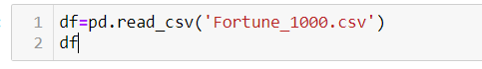

**Importing the required libraries**

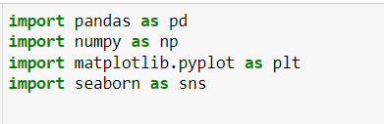

# - Clean the data by handling missing values, removing duplicates, and standardizing units.

### Data cleaning

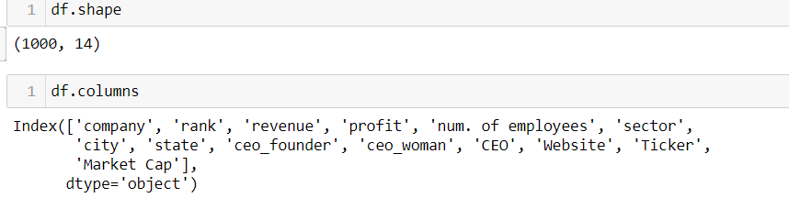



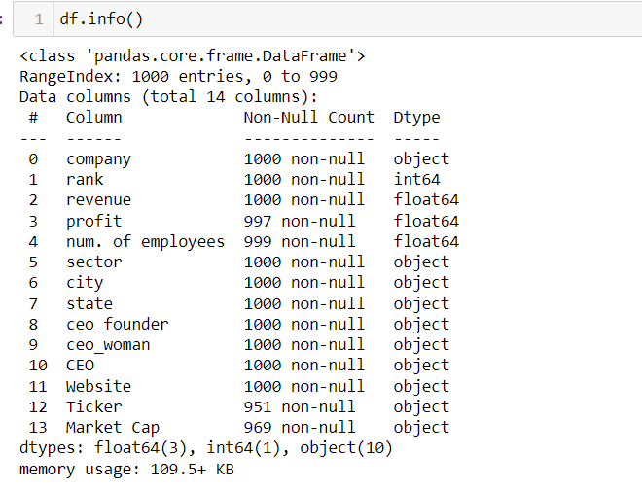

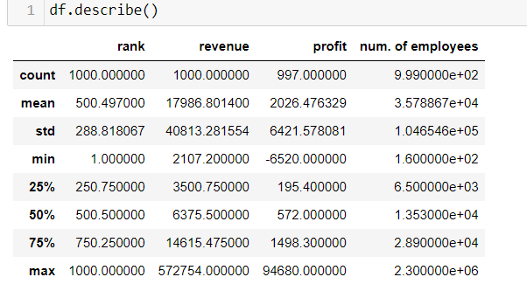

### checking for null values

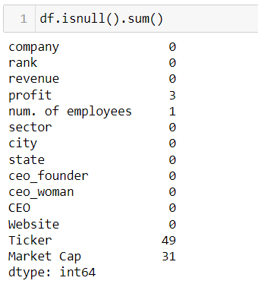

### removing null values

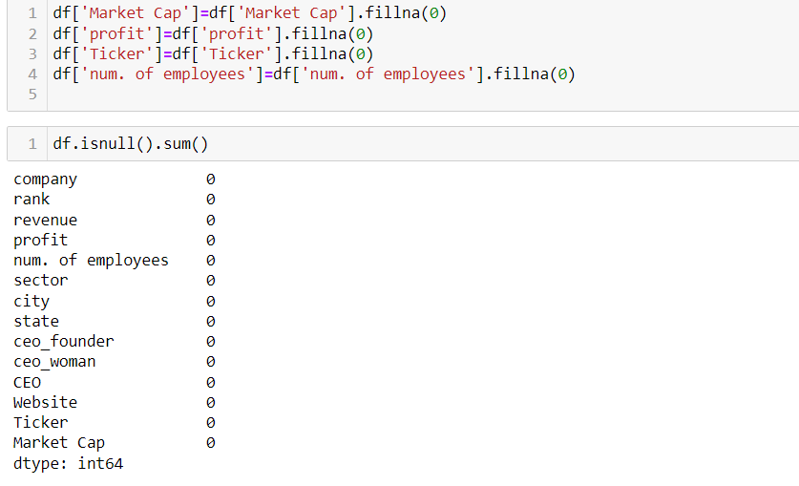

# **3. Data Analysis:**

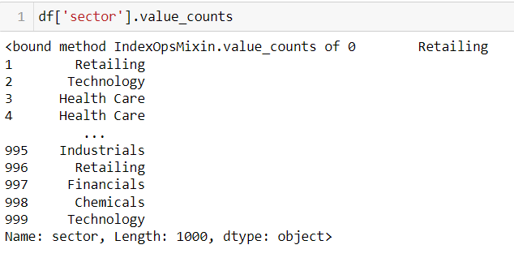

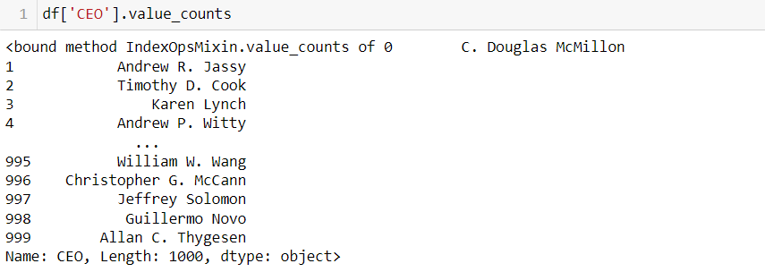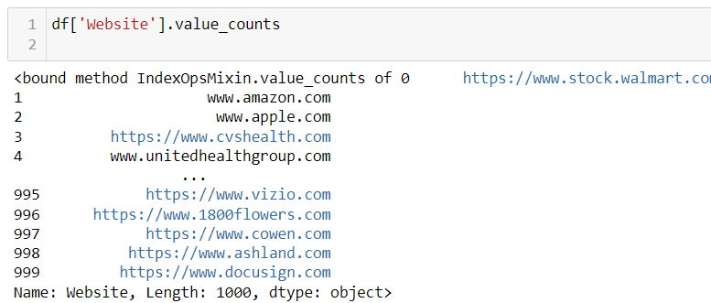

# - Utilize Python libraries like pandas, NumPy, and scikit-learn for data

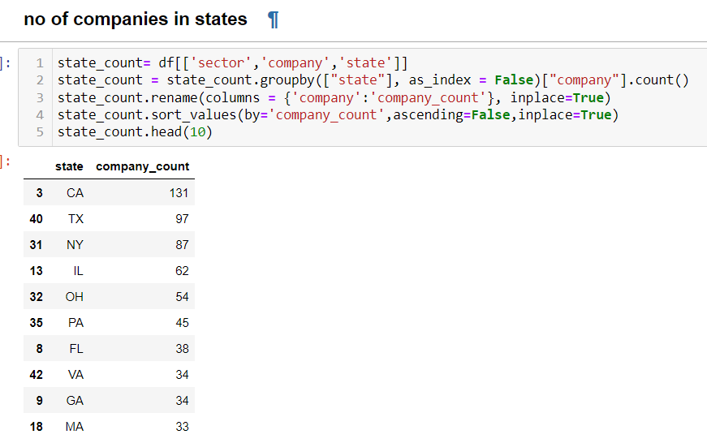

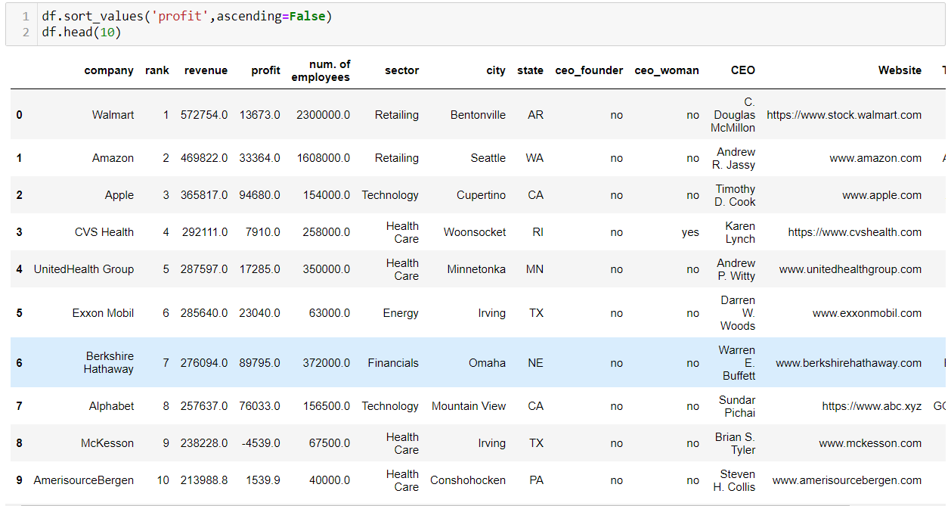

# .

# - Use libraries like matplotlib, Seaborn, or Plotly to create visualizations.

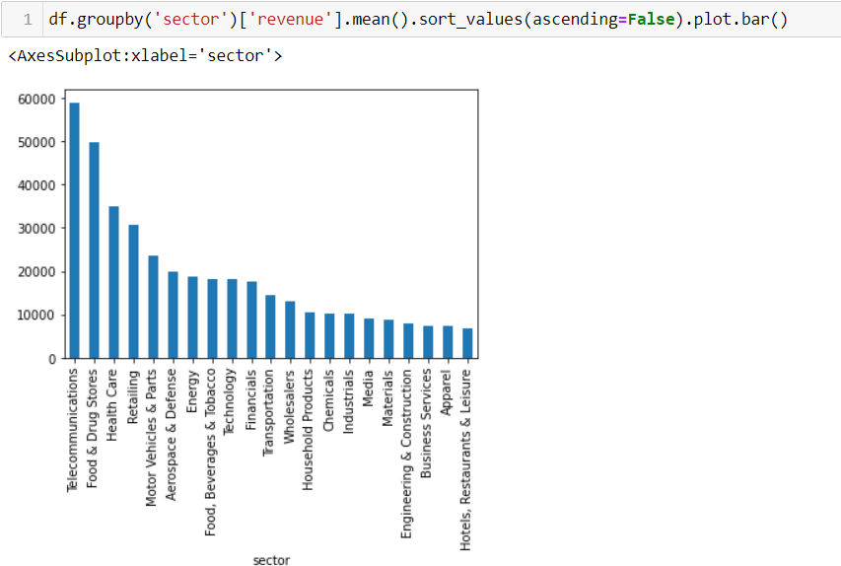

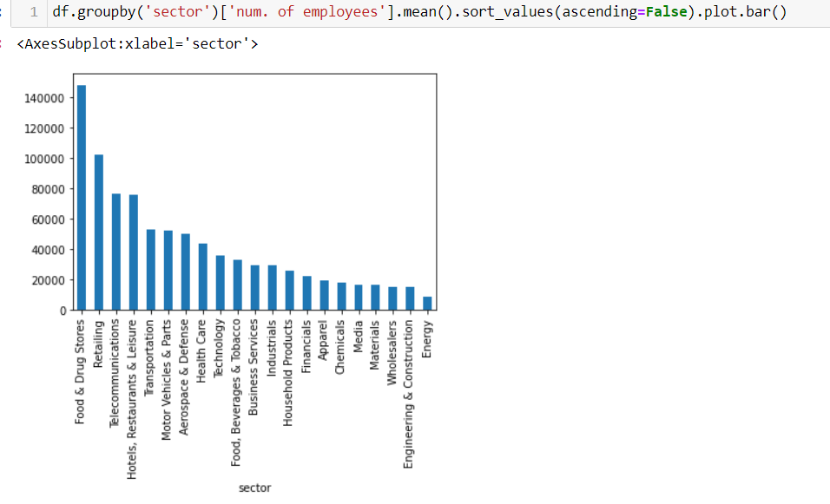

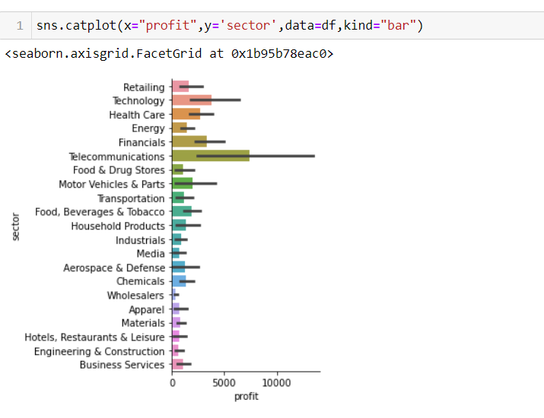

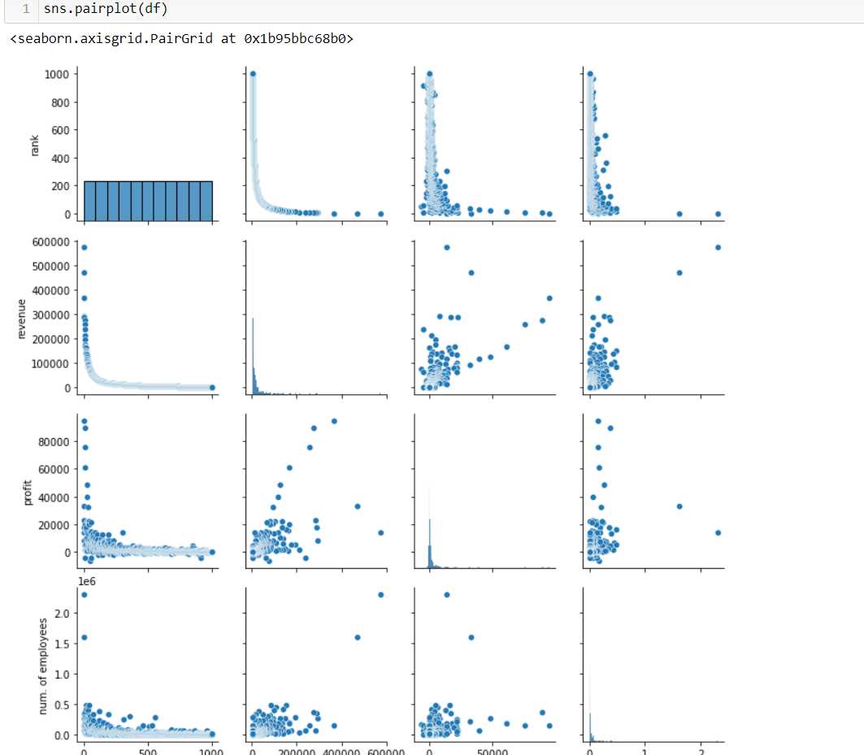

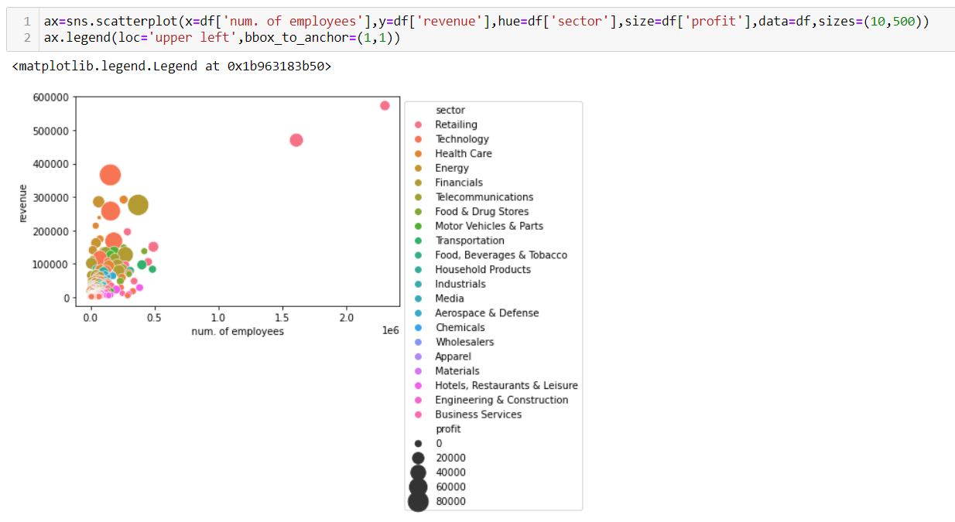

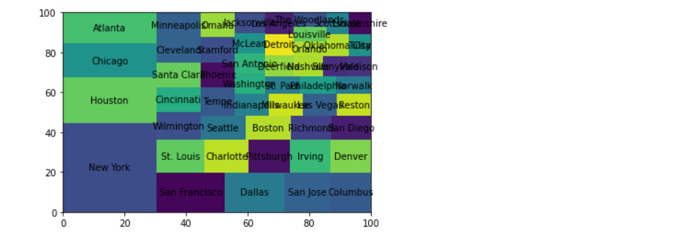

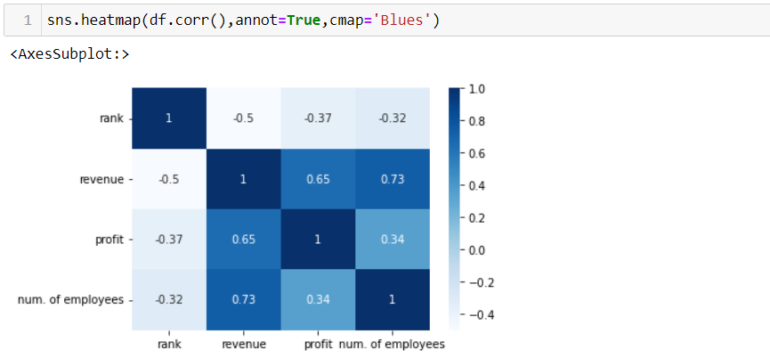

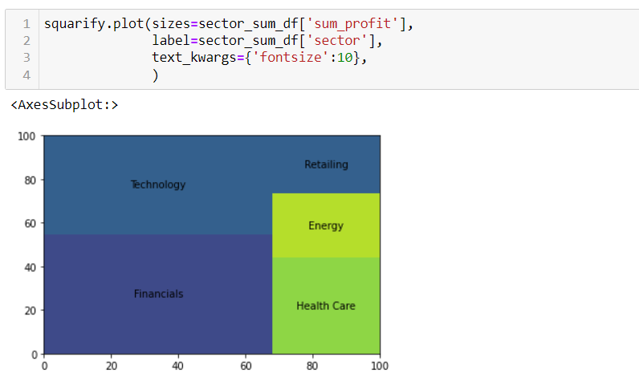

# **11. Iteration and Refinement:**

# - Review the analysis and visualization results.

# - Iterate and refine the analysis based on feedback and new insights.

# Remember that the implementation process can vary depending on your technical skills and the tools you're comfortable with. You might need to write Python scripts, create Jupyter Notebooks, or use other data analysis platforms. Additionally, breaking down the analysis into manageable chunks and building up from there can help you maintain clarity and manage the complexity of the project.

# It's also important to adapt the implementation to the specific goals of your analysis. As you progress, you'll likely encounter challenges, and troubleshooting will be an integral part of the process. Overall, the goal is to transform raw data into actionable insights that provide valuable information about the 2022 Fortune 1000 companies.

# 6. CONCLUSION

In conclusion, the comprehensive analysis conducted on the 2022 Fortune 1000 companies has yielded valuable insights into the dynamic landscape of contemporary business. This endeavor encompassed meticulous data collection, preprocessing, analysis, and visualization, culminating in a deeper understanding of the trends, challenges, and opportunities that shape these corporate giants.

The analysis unveiled significant trends across sectors, highlighting the dominance of technology-driven industries in revenue growth and innovation. Notably, companies embracing digital transformation showcased higher adaptability and resilience in the face of disruptions. This underscores the paramount importance of technology as a strategic driver for sustainable growth.

Workforce dynamics emerged as a critical factor influencing performance. The correlation between employee well-being initiatives, diversity measures, and financial success emphasized the significance of a motivated and inclusive workforce. Moreover, the analysis illuminated the role of innovation in fostering competitiveness and the urgency of aligning strategies with rapidly evolving technological landscapes.

The exploration of sustainability practices and social impact underscored a shifting paradigm where companies with strong ESG commitments exhibited not only responsible business conduct but also financial outperformance. This convergence of ethical practices and economic success emphasizes the potential for businesses to contribute positively to society while securing their own prosperity.

The culmination of data visualization and reporting transformed raw numbers into compelling narratives. Interactive visualizations provided a dynamic way to explore trends, making the analysis accessible to a wider audience. The insights shared in the comprehensive report offer actionable takeaways for businesses aiming to navigate the complexities of the modern market environment.

As with any analysis, limitations were acknowledged, including the constraints of publicly available data and the rapidly changing nature of business dynamics. However, this analysis provides a robust foundation for further research, strategic decision-making, and deeper exploration into specific industries and metrics.

In essence, the analysis on the 2022 Fortune 1000 companies serves as a testament to the power of data-driven insights in deciphering the multifaceted realm of business. By unraveling trends, unearthing correlations, and unveiling opportunities, this analysis facilitates an informed perspective that can guide organizations toward sustained growth, innovation, and meaningful impact in the ever-evolving corporate landscape.